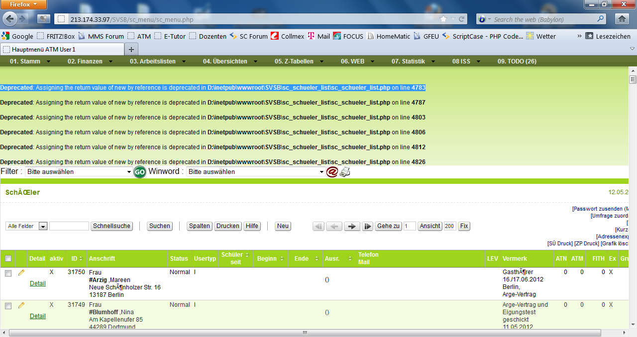

In code it’s this line
$Con_Mail =& new Swift_Connection_SMTP($smtp, 465, SWIFT_SMTP_ENC_TLS);

The new command is no longer supported in PHP 5.3.

How can I hide this error message in V5. I can’t use PHP 5.2 any longer because SC is running on Windows 2008 R2 with MYSQL 5.5
The own error handling of SC ignores the settings in PHP.INI like
display_errors = Off

