This is my database connection on webserver :
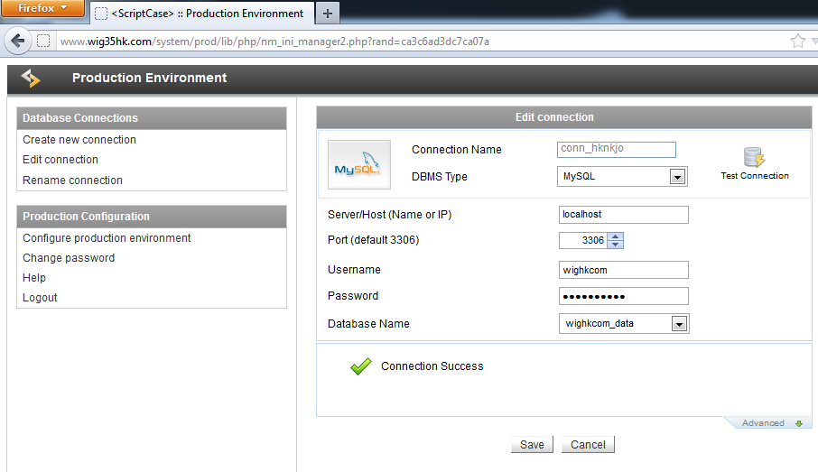

When I restart my computer and accessing my website url : http://www.wig35hk.com/? I got this error
In Indonesian language = ( “ connection to database not found , call the system administrator . connection : conn_hknkjo “)
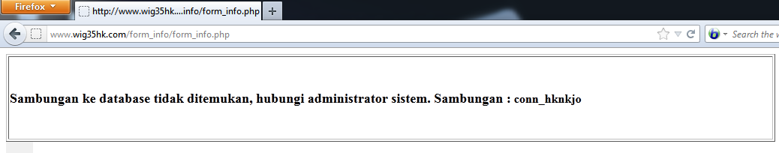
Then I try something..( I open the production environment ) :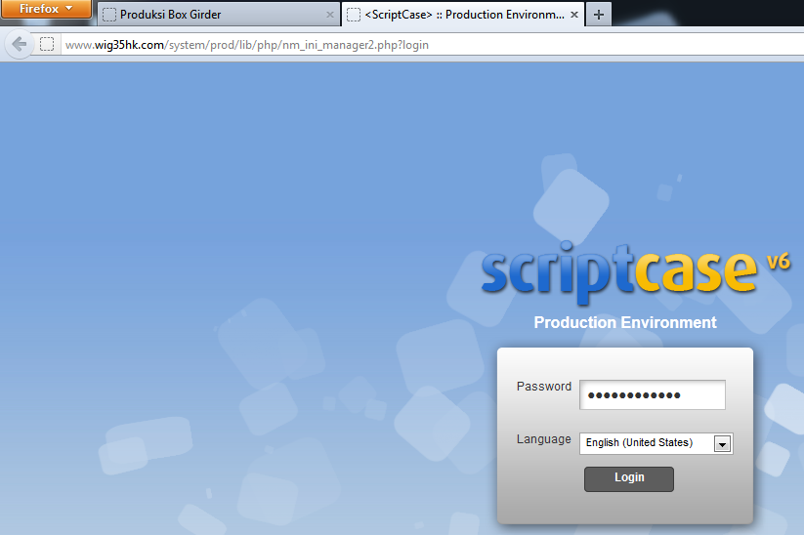
Then I try again to open my website url : http://www.wig35hk.com/?, and I found it work :
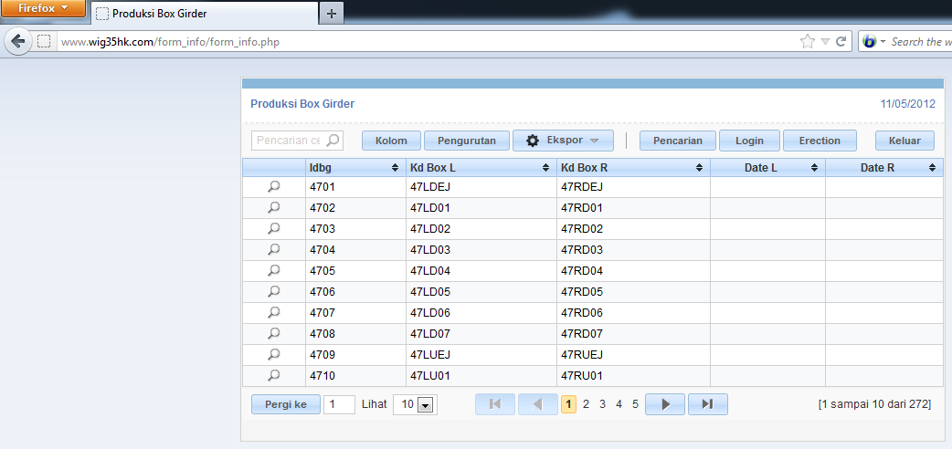
Then I close the Production Environment and try to access the url, it still working.While this condition I try to open my url from mobile , I found this error : in Indonesian language = ( “ connection to database not found , call the system administrator . connection : conn_hknkjo “)

